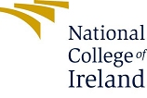

National College of Ireland

Project Submission Sheet

Student Name: | ………………Jestina…Jiji…………………………………………………………………………………………
Student ID: | ……………x22157301………………………………………………………
Programme: | …MA HRM…………………………………… | Year: | …2023-2024…
Module: | ……International Human Resource Management…………………………………………………………………………
Lecturer: | …Lorraine Dillon………………………………………………………………………………………………
Submission Due Date: | ………16th October 2023………………………………………………………………
Project Title: | … Hindustan Unilever Limited ……………………………………………………
Word Count: | ……3111…………………………………………………………………………………………………………

I hereby certify that the information contained in this (my submission) is information pertaining to research I conducted for this project. All information other than my own contribution will be fully referenced and listed in the relevant bibliography section at the rear of the project.
ALL internet material must be referenced in the references section. Students are encouraged to use the Harvard Referencing Standard supplied by the Library. To use other author's written or electronic work is illegal (plagiarism) and may result in disciplinary action. Students may be required to undergo a viva (oral examination) if there is suspicion about the validity of their submitted work.

Signature: | ………………………………………………………………………………………………………………
Date: | ……16th October 2023………………………………………………………

PLEASE READ THE FOLLOWING INSTRUCTIONS:

1. Please attach a completed copy of this sheet to each project (including multiple copies).
2. Projects should be submitted to your Programme Coordinator.
3. You must ensure that you retain a HARD COPY of ALL projects, both for your own reference and in case a project is lost or mislaid. It is not sufficient to keep a copy on computer. Please do not bind projects or place in covers unless specifically requested.
4. You must ensure that all projects are submitted to your Programme Coordinator on or before the required submission date. Late submissions will incur penalties.
5. All projects must be submitted and passed in order to successfully complete the year. Any project/assignment not submitted will be marked as a fail

Office Use Only
Signature:
Date:
Penalty Applied (if applicable):

AI Acknowledgement Supplement

[Insert Module Name]

[Insert Title of your assignment]

Your Name/Student Number | Course | Date

This section is a supplement to the main assignment, to be used if AI was used in any capacity in the creation of your assignment; if you have queries about how to do this, please contact your lecturer. For an example of how to fill these sections out, please click here.

AI Acknowledgment
This section acknowledges the AI tools that were utilized in the process of completing this assignment.
Tool Name | Brief Description | Link to tool
Description of AI Usage
This section provides a more detailed description of how the AI tools were used in the assignment. It includes information about the prompts given to the AI tool, the responses received, and how these responses were utilized or modified in the assignment. One table should be used for each tool used.
[Insert Tool Name]
[Insert Description of use]
[Insert Sample prompt] | [Insert Sample response]

Evidence of AI Usage
This section includes evidence of significant prompts and responses used or generated through the AI tool. It should provide a clear understanding of the extent to which the AI tool was used in the assignment. Evidence may be attached via screenshots or text.
Additional Evidence:
[Place evidence here]
Additional Evidence:
[Place evidence here]

INTRODUCTION

Unilever India, officially known as ​Hindustan Unilever Limited (HUL​), is a dominant force in the Indian consumer products market. The company's history in India dates to the late 19th century, when it established its first soap factory in Bombay (now Mumbai), under the name Lever Brothers India Limited. HUL ​is a division of the British-​​Dutch multinational corporation Unilever​, which operates in more than 190 nations worldwide. The path of HUL in India has been characterized by an unwavering dedication to quality and innovation. It has developed over time to become one of the biggest and most established consumer products corporations in the nation. The company is synonymous with brands including Surf Excel, Lux, Dove, Pepsodent, Knorr, and many others. HUL has had a huge impact on ​the Fast-Moving Consumer​ ​Goods (FMCG) industry in India​. (Krishnan & Thomas, 2010).

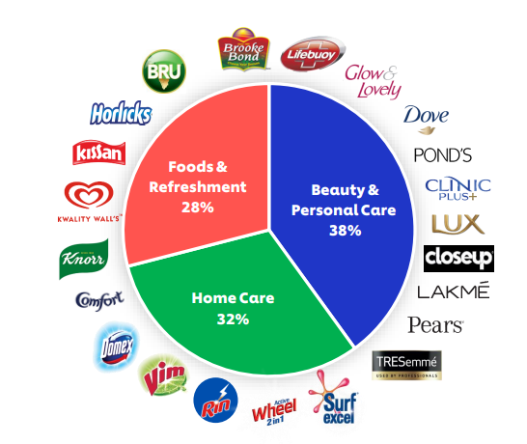

​​Figure 1​. Hindustan Unilever Limited Product Portfolio (Sharma, 2023)

According to Chandni & M (2023) HUL competes in a thriving industry that is highly cutthroat. India's FMCG sector is characterised by a growing middle class, rapid urbanisation, and shifting consumer preferences. The demand for products that are both healthy and ecologically friendly has increased as consumers grow more concerned with the environment and their health. The development of digital platforms and e-commerce has also significantly altered how consumers shop. In reaction to these evolving market realities, HUL has shown amazing agility. The company continuously innovates its product lineup to meet shifting consumer needs. It places a strong emphasis on sustainability, which entails reducing its negative effects on the environment and obtaining raw materials responsibly. HUL has embraced digitalization in marketing and distribution to stay in contact with its customers. In the current trading environment, HUL's methods are designed to address both these problems and the opportunities they bring. To continue to dominate the market in several product categories, the company makes use of both its enormous distribution network and its in-depth understanding of the Indian consumer.

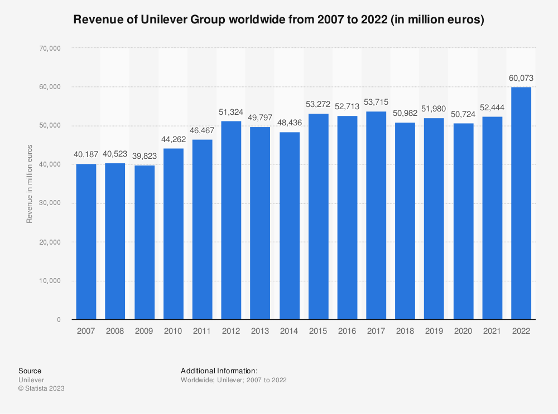

Figure 2. Revenue of Unilever 2007 to 2022 (Petruzzi, 2023)

Aims and Objectives:

HUL's main goal is to fulfil people's necessities while preserving its company's long-term viability. The business has outlined a thorough set of goals to accomplish this overarching purpose (Basak, 2017).

Market leadership: HUL wants to keep up its dominance in the FMCG industry. It continually aims to innovate, broaden its product offering, and uphold consumer confidence. Market dominance enables the business to establish norms and trends for the sector.
Sustainable Sourcing: HUL emphasizes the importance of ethical sourcing. The business is dedicated to using ethical and sustainable procurement methods for raw materials. This dedication guarantees the long-term availability of essential ingredients for its goods in addition to being consistent with global sustainability standards.

Lessening the impact on the environment: Sustainability is a key component of HUL's business strategy. The company is committed to eliminating waste, saving resources, and cutting emissions in order to lessen its environmental impact. This is in line with the larger environmental stewardship movement.

Delivering High-Quality Products: HUL's goals are based on quality. The business is committed to providing customers with high-quality, secure, and dependable products. Its reputation and customers' loyalty have both benefited from this dedication to quality.

Approach to Human Resources:

HUL places a high priority on its people, seeing them as essential resources for achieving its goals. Progressive policies and procedures that promote a loving, inclusive, and supportive workplace environment describe the company's approach to human resources (Gandhi, 2019).

Talent Development: To discover, foster, and promote leadership inside the organization, HUL has put in place a strong talent development and management framework. ​To make sure that​ its staff is ​prepared to handle the​ difficulties of a competitive economy, the organization makes investments in ongoing learning and development.
Employee Welfare: HUL is dedicated to the welfare of its staff. To promote the physical and mental health of its staff, the company offers a variety of employee perks and a safe and healthy work environment. These actions support an engaged and motivated staff.

Diversity & Inclusion: HUL supports an inclusive working atmosphere and values diversity. The business supports using the strength of many viewpoints and experiences to stimulate innovation and creativity. Gender equality, age, ethnicity, and other factors are all included in HUL's dedication to diversity and inclusion.

Ethical Conduct and Integrity: HUL places a high value on ethical conduct and integrity in all of its HR processes. This comprises ethical hiring procedures, fair and open HR regulations, and a significant emphasis on worker ethics and corporate governance.

A Cultural Survival Guide for Hindustan Unilever's Global Managers

According to (K.J & Reddy, 2023) it's exciting yet difficult to work and live as a Parent nation National (PCN) in a foreign nation like India. It's essential to successfully negotiate the cultural, professional, and personal components of the host country if you want to guarantee a successful and rewarding stay. The lessons from the Hofstede, Trompenaars & Hampden-Turner, and GLOBE studies are used to create this survival guide, which is intended for Managers of Hindustan Unilever Limited.

· Recognize the Cultural Aspects (Hofstede):
The values of solidarity, high power distance, avoiding uncertainty, and long-term thinking are strongly ingrained in Indian society. Forging solid connections and establishing reasonable expectations require an understanding of these elements. Accept the cultural norms and hierarchical structure that guide daily interactions.

· Establish Trustworthy Relationships:
In India, success is built on trust. Create a strong network of local business partners, government representatives, and employees. Be humble in your relationships and respect the hierarchical structure. Demonstrate a sincere interest in the lives of others.

· Modify Your Leadership Style:
It's crucial to strike a balance between universal truths and regional realities. Change your leadership approach to integrate Indian ideals with international policies. Recognize the importance of situation-specific choices while upholding the broad corporate objectives.

· Adopt Local Values:
Indian culture is strongly influenced by Indian values and rituals. Learn about local festivals, customs, and etiquette to better immerse oneself in the culture. Participating in these rituals will strengthen your relationships and promote respect and trust.

· Communicate Effectively:
Even though English is widely spoken, pay attention to subtleties in communication. In your conversations, be clear and patient, and where appropriate, think about speaking the local language. Understanding and cooperation are fostered through effective communication.

· Handle Bureaucracy:
The bureaucracy in India can be complex and time-consuming. Use your local knowledge to efficiently navigate legal and administrative processes while interacting with government agencies. Establish connections with influential parties who can hasten the process.

· Be Flexible (GLOBE Study):

The GLOBE study emphasizes how corporate and societal culture affect leadership and management strategies. Keep an open mind and be willing to modify your strategy to suit local expectations. Be aware that the organizational culture may not be the same as the one in your nation.

In conclusion, a PCN's life and work in India is filled with both chances and difficulties. This thorough survival manual offers a road plan for a fruitful journey by drawing information from the Hofstede, Trompenaars & Hampden-Turner, and GLOBE investigations. Adopt the culture, establish connections, modify your leadership approach, and place a high priority on learning and development. You will not only succeed in your position at Hindustan Unilever Limited if you abide by these rules, but you will also improve both your personal and professional life in India.

​​Issues relating to the Organizational Culture of the Parent Country Headquarters​ ​(PCNs).

As per the study by (Yadav, 2012) when managing global operations, it is crucial to take organizational culture issues from Parent Country Headquarters (PCNs) into account because they have a big impact on how well subsidiaries and global teams perform. There are numerous important concerns to address in the context of Hindustan Unilever Limited, which has its parent company in the UK.

Cultural Conflict: There might be a cultural conflict when PCNs, who are frequently firmly ingrained in the customs and traditions of the parent nation, visit a subsidiary nation like India. They could bring expectations, ways of communicating, and ways of making decisions that are out of step with the local culture, which can cause misunderstandings and disputes.
PCNs could be reluctant to modify their procedures to fit the regional culture. It may be difficult for them to embrace and implement the adjustments required for success in the host country due to their loyalty to the organizational culture of the home firm. This reluctance ​may make it more difficult for​ the business to adapt ​to changes in the​ local market.

Communication issues: PCNs frequently have a strong affinity for the vocabulary and communication patterns used by the parent company. Effective communication is essential in India, where regional dialects and cultural quirks are important considerations. PCNs must develop the ability to modify their communication styles to be more effective and inclusive in a diverse workplace.
PCNs occasionally display ethnocentrism, which is the idea that their own culture and ways of life are superior. Collaboration and the integration of local staff may be hampered by this approach. Fostering an inclusive workplace environment where local employees' ideas and talents are acknowledged is crucial.

Talent Development and Retention: Compared to the host country, PCNs could have different expectations for talent development and retention. For instance, career development and growth opportunities are highly valued in India. Retaining excellent talent requires striking a balance between these expectations and the parent company's standards.
Choosing Locally vs. Globally: It can be extremely difficult to balance local and global decision-making. While local realities may call for more decentralized decision-making, PCNs may tend to concentrate decision-making at the headquarters.

In the context of PCNs functioning in India, the interaction of cultural conflict, communication difficulties, talent development, and decision-making is a delicate balancing act. Success depends on bridging the cultural divide between the subsidiary nation and the parent enterprise. To encourage collaboration, PCNs must embrace adaptation, promote open communication, and put an end to ethnocentrism. Additionally, it is crucial to align local and international decision-making procedures and talent development techniques. The best of both worlds must be harmoniously blended by PCNs and local teams to successfully navigate these challenges, guaranteeing long-term success in the Indian market.

​​

Issues relating to Context and Environment of the Host Country (HCNs​):

Before entering into a new country, a company should be fully aware and have analysed the context and environment that will impact their human resource policies and practices. As per Yamao et al., (2020), the major actors in newly assigned locations are ​host country nationals (HCNs), or local staff members in foreign​ ​subsidiaries of multinational enterprises​. When a company like Hindustan Unilever Limited, is planning to enter the Indian market there are key factors that need to be considered, economic, political, legal, and technological landscapes. These factors are uncontrollable in nature and can impact business decisions to a certain extent (IIMM, 2019). The Indian economy is in a growing state, and it is the middle-class families that are driving this change. Further to which the growth of the Indian economy is hindered by factors like poverty, gender and income inequality.

India is the biggest democracy in the world and from a political standpoint, it is also very much stable. But factors like bureaucracy and corruption create complications for businesses. The advanced usage of technology by the locals in the form of Internet and smartphone usage has helped in the cultivation of a digital community and to a certain extent in shaping consumer behaviour. Some complexities that the MNCs could face is regarding regulations surrounding foreign investment, intellectual property, labour laws, and taxation. Studies conducted by Saxena (2022) suggest that the youth in India plays a keen role in the country’s development. Thus, to attract the needed talents, companies should showcase competitive compensation and benefits benchmarked to the related sectors. Providing the needed training to meet local needs along with performance-based incentives would highlight the long-term career growth and retention opportunities of the firm. Hindustan Unilever must balance localization with global integration in its subsidiary HR strategy and design. Adaption of the sectors economic, political, legal and technological will enable HU to source, manage and retain local talent.

Issues relating to Sourcing HR for HCNs

Putting mechanisms in place to recruit, identify, develop, engage, maintain, and deploy people who are important to a business is known as talent management, according to CIPD (2023). It must be in line with strategic corporate goals to be effective. Thus, Hindustan Unilever must balance localization with consistency for operational success. To attract the much-needed talent, companies should partner up with head-hunters for talent acquisition. The main job portals in India like Naukri, LinkedIn, Indeed and Monster could help in targeted outreach to passive candidates. Hiring from Top campuses in India like IITs, IIMs and BITS, taps into graduate talent. Competitive pay, career growth and work culture must be highlighted to compete with IT/tech companies (Paul, 2013). Talent selection should be mainly focused on role-related skills and competencies along with measuring the cultural fit. Techniques like behavioural interviews and assessment centres can align to global best practices. Local language ability should be evaluated when relevant. Companies implementing the Ai based hiring can help in reducing hiring time, storing much-needed data and costs along eliminating hiring based on bias. Onboarding is vital for integrating new hires. A buddy system can accelerate learning. Documentation and systems training ensure readiness from day one. Early exposure to company values and culture enables connection. Feedback mechanisms foster two-way dialogue. Blending global consistency with local adaptation will attract and integrate high-potential hires for Hindustan Unilever.

Issues relating to Performance Management of HCNs

Hindustan Unilever should focus on performance management to drive productivity and retention. Soma factors to be considered while managing the performance include Aligning goals and metrics to local strategic priorities while maintaining global consistency. Collaborating with Indian managers to set realistic and motivating targets. linking rewards directly to performance is the second factor in, customizing appraisal processes to suit Indian cultural preferences (Wang, 2012). 360-degree feedback and frequent informal reviews supplement annual reviews. The third factor ​would be to​ provide much-needed ​training to the managers​ which could eliminate the bias in their decision-making and promote fair and consistent practices. Leveraging technology like digital tools and apps further streamlines efficient systems and processes Finally, ensuring alignment between performance management and succession planning retains and progresses top talent within the local Indian subsidiary (Kuruvilla & Ranganathan, 2010). By getting performance management right, Hindustan Unilever can optimize subsidiary productivity and retain a high-performing Indian workforce.

Issues relating to the Training and Development of HCNs

​​Fostering professional growth and development is an ongoing process​ and requires ​strategic planning​. Training and development are critical for Hindustan Unilever to enhance the skills and capabilities of local talent in India. This fact is especially true when addressing various challenges in training and development for your team. Issues relating to the Training and Development of HCNs. The first step that needs to be considered is analysing the gap in skills, by understanding the current set of skills and desired set of skills (Rao, 2016). Data inputs like performance reviews, manager feedback and employee surveys provide insights on developmental areas related to role competencies, leadership behaviours, technical abilities etc. Alignment to long-term career trajectories is also considered (Yadapadithaya, 2001). The training programs should be addressed in such a manner that identified needs are addressed. For technical skills, on-the-job training like job shadowing and mentorship leverage the experience of seasoned employees. Classroom programs focused on topics like sales, marketing, finance, operations, etc impart functional knowledge. Online learning via virtual platforms enables scalable delivery with flexibility. Mandatory compliance training is also incorporated. Cross-cultural training is essential for integrating local hires into the global organizational culture (Hou et al., 2013). Sensitizing expat managers to local norms and perspectives can also minimize miscommunication. Change management training aids adaptation to evolving business strategies and structures. Delivery combines instructor-led sessions, e-learning, on-the-job experiences, stretch assignments and coaching. Learning is reinforced through training manuals, job aids, peer discussions and assessments. Facilities like dedicated development centres provide supportive infrastructure (Biswal and Sahoo, 2023). A feedback system should also be implemented that would assess the gained knowledge and tracking impact on performance metrics calculates ROI and guides continual improvement.

Conclusion

Managing human resources across global and local contexts poses complex challenges for multinational enterprises like Hindustan Unilever. As the analysis indicates, balancing consistency in policies and processes while adapting to India's unique talent landscape and environment is crucial but difficult to achieve. Fundamentally, parent country managers must evolve their leadership approaches to integrate global vision with local realities. Letting go of ethnocentric mindsets and embracing cross-cultural learning is vital. The subsidiary HR strategy must also balance global standardization with customization to the Indian context through constant collaboration between global and local teams. Localization is key when sourcing talent, by recruiting and onboarding in alignment with India's needs but within overall global competency frameworks. Performance management processes require cultural adaptation while linking individual development to global strategic priorities. Training should assess local needs while building cross-cultural awareness across geographies.
Two-way communication, knowledge exchange and respect for diversity across the entire organizational system enables effective global-local coordination. Leveraging India's strengths including its vast talent pool and growing economy unlocks the subsidiary's growth potential. In today's globalized world, the ability to manage cross-border talent flows while bridging cultures is a key competitive advantage. Hindustan Unilever can achieve this by blending consistency, localization and diversity, unlocking the best of global and local. The rewards of this balanced approach are sustainable growth and progress for the enterprise.

Recommendation

Hindustan Unilever should put a high priority on ongoing cross-cultural training, encourage open two-way communication, and promote a culture of diversity and inclusion throughout the organization to effectively address these challenges and take advantage of India's strengths. By doing this, the company will be able to leverage both international standards and local insights for long-term growth and success.

In the Indian setting, Hindustan Unilever (HUL) should put its attention on a thorough strategy for managing human resources. This means putting a priority on cross-cultural training, encouraging open dialogue, and cultivating an inclusive culture across the entire organization. It's critical to strike the correct balance between localization and global standardization when it comes to HR policies, hiring, and performance evaluation. HUL should seek out talent through regional and international networks, while promoting its distinctive corporate culture and providing competitive pay. Additionally, specialized training programmes and performance management methods can improve capabilities and align staff with overall strategy aims. By putting these tactics into practice, HUL can manage international talent flows while overcoming cultural gaps, resulting in long-term success and growth for the company.

References

- About IIMM. ​Business Environment. (2019). https://iimm.org/wp-​​content/uploads/2019/04/IIMM_BE_Book.pdf​
- ​​Basak, R. (2017). Liquidity versus profitability: A study on Hindustan Unilever Limited.​ ​MANTHAN: Journal of Commerce and Management, 4(01).​ ​https://doi.org/10.17492/manthan.v4i01.9611​
- Biswal, P. and ​Sahoo, C.K., (2023). Customised training programme for the indigenous​ ​population: a systematic review. Industrial and Commercial Training​.
- Conceptual issues relating to organisational culture. (2022b). ​Handbook of Research​ ​Methods for Organisational Culture​, 4–4. ​https://doi.org/10.4337/9781788976268​.00007
- ​​Gandhi, S. (2019). An insight into the governance disclosures of Hindustan Unilever​ ​Limited. International Journal of Management Studies, VI (4​), 70. https://​doi.org/10.18843/ijms/v6i4/10​
- ​​Hou, N., Fan, J., Tan, J.A., Hua, J. and Valdez, G., 2018. Cross-cultural training​ ​effectiveness: Does when the training is delivered matter. International Journal of​ ​Intercultural Relations, 65, pp.17-29​.
- K.J, Ms. S., & Reddy, Dr. G. S. (2023). ​Sustainable development through project​ ​prabhat – A case study of hindustan unilever limited​. ​International Journal of Research​ ​Publication and Reviews, 4(5​), 5121–5125. ​https://doi.org/10.55248/gengpi.4.523​.42991
- ​​Krishnan, T. N., &Thomas, J. (2010). Hindustan Unilever Limited: Aligning Talent​ ​Strategy to Address Marketing Challenges. https://doi.org/10.4135/9781529708790​
- ​​Kuruvilla, S. and Ranganathan, A., (2010). Globalisation and outsourcing: confronting​ ​new human resource challenges in India's business process outsourcing​ ​industry. Industrial Relations Journal, 41(2), pp.136-153​.
- ​​Paul, S., (2018). An analysis of the skill shortage problems in Indian IT​ ​companies. Social Sciences, 7(9), p.159​.
- ​​Petruzzi, D. (2023) Annual revenue of Unilever 2022. Statista.​ ​https://www.statista.com/statistics/269190/global-revenue-of-the-unilever-group-since-​2007/
- ​​Rao, M.S., (2016). Tools and techniques to ensure innovative management education​ ​in India. Industrial and Commercial training, 48(5​), pp.265-268.
- S. Chandni, P., & M, V. (2023). Working Capital Management of Hindustan Unilever Limited. ​PARIPEX INDIAN JOURNAL OF RESEARCH​, 3–5. ​https://doi.org/10.36106/paripex​/3806407
- Saxena, N. and Khandelwal, A.R., 2022. Effectiveness of E‐HRM Tools Using the ​Functionalities of Artificial Intelligence During Remote Working in Lockdown​ ​Period. Impact of Artificial Intelligence on Organizational Transformation, pp.387-397​.
- Sharma , A. (​2023). Hindustan Unilever Limited. Stocx.​ ​https://www.stocx.in/article/hindustan-unilever-limited​
- ​​Talent management: Factsheets. CIPD​. (2023). ​https://www.cipd.org/en/knowledge/factsheets/talent-factsheet​/
- Wang, V.C., (​2012). Human Performance Models Revealed in the Global​ ​Context. Human Resource Management International Digest, 20(3​).
- ​​Yadapadithaya, P.S., (2001). Evaluating corporate training and development: an Indian​ ​experience. International Journal of Training and Development, 5(4), pp.261-274​.
- ​​Yadav, H. (2012). Study of the BCG matrix for Hindustan Unilever Limited. SSRN​ ​Electronic Journal. https://doi.org/10.2139/ssrn.2124042​
- ​​Yamao, Sachiko; Yoshikawa, Toru; Choi, Daejeong; Toh, Soo Min (​​2020). When do​ ​host country nationals help expatriates? The roles of identification with the​ ​multinational enterprise and career development support by the subsidiary. Journal of​ ​International Management, 26(3), 100778–.​ ​doi: 10.1016/j.intman.2020.100778​

